Table of Contents

Add css into index php 1

Add img src 1

# Add css into index php

<link rel="stylesheet" href="<?php bloginfo('stylesheet_url');?>">

Css located in root folder

# Add img src

<img src="<?php bloginfo('template_url'); ?>/images/logo.png" alt="Logo">

Images located in images folder

# Head of the page

<html <?php language_attributes(); ?>>

<head>

<meta charset="<?php bloginfo('charset'); ?>">

<meta name="viewport" content="width=device-width, initial-scale=1.0">

<meta name="description" content="<?php bloginfo('description');?>">

<title>

<?php bloginfo('name');?> |

<?php is_front_page() ? bloginfo('description') : wp_title();?>

</title>

<!-- Compiled and minified CSS -->

<link rel="stylesheet" href="https://cdnjs.cloudflare.com/ajax/libs/materialize/0.100.2/css/materialize.min.css">

<!--Let browser know website is optimized for mobile-->

<meta name="viewport" content="width=device-width, initial-scale=1.0" />

<link rel="stylesheet" href="<?php bloginfo('stylesheet_url');?>">

<link href="https://fonts.googleapis.com/css?family=Roboto:300,900" rel="stylesheet">

<?php wp_head();?>

</head>

# Add admin bar

</footer>

<?php wp_footer();?>

</div>

</div>

# Include header file

<?php get_header();?>

Include footer file

<?php get_footer();?>

Menu

Лого навигация на домашнюю страницу

Header.php

<a href="<?php echo get_option("siteurl"); ?>" class="brand-logo">

Нав бар

<https://github.com/Kail0/wp-materialize-navwalker> - дроп даун от гугл

Functions.php

<?php

//register nav walker class for dropdown menu #1

require_once 'class-wp-bootstrap-navwalker.php';

require_once get_template_directory() . '/wp_materialize_navwalker.php';

//theme support #2 st_ - prefix for this theme

function st_theme_setup()

{

//nav menus support #3

register_nav_menus(

array(

'primary' => __( 'Primary Menu', 'THEMENAME' ),

)

);

}

//add hoock and action to run that function after setup theme #4

add_action('after_setup_theme', 'st_theme_setup');

header.php

<div id="nav-mobile" class="right hide-on-med-and-down">

<?php

// MATERIALIZE DROP MENU

wp_nav_menu( array(

'menu' => 'primary',

'theme_location' => 'primary',

'menu_class' => 'hide-on-med-and-down',

'walker' => new wp_materialize_navwalker()

) ); ?>

</div>

Post loop

<https://codex.wordpress.org/The_Loop>

**Shorten content**

Index.php

<?php the_excerpt();?>

Function.php

//Excerpt length control

function st_set_excerpt_length(){

return 20;

}

//hook for excerpt

add_filter('excerpt_length','st_set_excerpt_length');

**Post thumbnails – Feature image in Admin panel**

Functions.php



function st_theme_setup()

{

add_theme_support('post-thumbnails');

**Render image on the page**

index.php

<?php if(has_post_thumbnail()) : ?>

<?php the_post_thumbnail(); ?>

<?php endif; ?>

**Single post page**

Create file single.php

**Comments**

In single.php

<?php the_content();?>

<?php comments_template();?>

**Pages template**

Create a file page.php

Sidebar

Initiate widgets

Function.php

// widgets locations#1

function st_init_widgets($id){

//init all widgets

register_sidebar(array(

'name' => 'Sidebar',

'id' => 'sidebar',

// any html before widget

'before_widget' => '<div class="sidebar-module">',

'after_widget' => '</div>',

'before_title' => '<h4>',

'after_title' => '</h4>'

));

}

//hook function init widget#2

add_action('widgets_init' , 'st_init_widgets');

render sidebar widget

file sidebar.php

<div class="blog-sidebar">

<!-- sidebar module -->

<?php if(is_active_sidebar('sidebar')): ?>

<?php dynamic_sidebar('sidebar');?>

<?php endif;?>

</div>

Then call to get side bar in template file like index.php

<?php get_sidebar();?>

**Pots formats**

Enable post formats

Function.php

*//post formats*add_theme_support('post-formats', array('aside','gallery'));

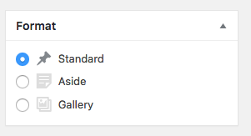

To format posts as format create special php files like

Aside

Content-aside.php

Update function call to use post formats

index.php

Before

<?php get_template_part('template-parts/content');?>

After

Put that update all over pages that use get_template_part call..

Then add a php code to content-aside.php file to render content

**Custom front page**

Creating the front home page

In WP create page home and blog

Go to settings>reading and reassign home page and posts page

Create file front-page.php to render home pages

Adding widgets for front page

1 register widgets in function.php

*//init widget box1 with robot*register_sidebar(array(  
 'name' => 'Box 1',  
 'id' => 'box1',  
 *// any html before widget* 'before_widget' => '<div class="subFigure">',  
 'after_widget' => '</div>'  
));  
  
*//init widget box2 with book*register_sidebar(array(  
 'name' => 'Box 2',  
 'id' => 'box2',  
 *// any html before widget* 'before_widget' => '<div class="subFigure">',  
 'after_widget' => '</div>'  
));  
  
*//init widget box3 with phone*register_sidebar(array(  
 'name' => 'Box 3',  
 'id' => 'box3',  
 *// any html before widget* 'before_widget' => '<div class="figure">',  
 'after_widget' => '</div>'  
));

2 edit widget content in wp admin

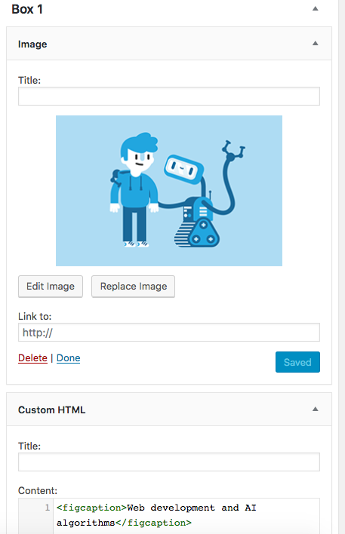

3 call widget on the page template like front-page.php

<?php if (is_active_sidebar('box1')): ?>  
 <?php dynamic_sidebar('box1'); ?>  
<?php endif; ?>

Archive and search pages

**Theme customizer api**

Go to functions.php and call customizer.php file

*//Link Customizer File*require get_template_directory(). '/inc/customizer.php';

Create a customizer.php

hook function

*//hook for function*add_action('customize_register', 'st_customize_register');

To create a new section in Customizer here follow the steps

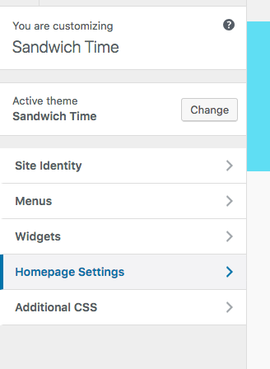

Fill function

<?php  
 function st_customize_register($wp_customize){  
 *//Showcase Section on front page  
 //add new section to customizer* $wp_customize->add_section('showcase' ,array(  
 'title' => __('Showcase', 'Sandwich Time'),  
 'description' => sprintf(__('Options for showcase', 'Sandwich Time')),  
 'priority' => 130  
 ));  
  
 *//default value for the setting Heading of showcase section* $wp_customize->add_setting('showcase_heading', array(  
 'default' => _x('Welcome To The Club', 'Sandwich Time'),  
 'type' => 'theme_mod'  
 ));  
  
 *//name of the setting* $wp_customize->add_control('showcase_heading', array(  
 'label'=> __('Heading' , 'Sandwich Time'),  
 'section' => 'showcase',  
 'priority' => 1  
 ));  
  
 }

Allow to web respond when changes published from customizer

Open front-page.php

Call showcase

Before

<div id=**"body"**>  
 <div class=**"container"**>  
 <div class=**"row"**>  
 <div class=**"center-align col s12"**>  
 <h5>**Welcome To The Club**</h5>  
 <p>**Super cool work for super cool dudes**</p>  
 </div>

After

<div id=**"body"**>  
 <div class=**"container"**>  
 <div class=**"row"**>  
 <div class=**"center-align col s12"**>  
 <h5><?php echo get_theme_mod('showcase_heading', 'Welcome To The Club');?></h5>  
 <p><?php echo get_theme_mod('showcase_text', 'Super cool work for super cool dudes');?></p>  
 </div>

Image customizer